EX NO 5: Eliminate dead code

AIM
To write a C program to perform dead code elimination in Three Address Code (TAC).
ALGORITHM
- Start the program.
- Read the Three Address Code statements until END is entered.
- Store each statement and separate the left-hand side (LHS) and right-hand side (RHS).
- Mark the final output variables as live.
- Check whether each statement is required by a live statement.
- Mark the statements that are needed for the final output.
- Remove the unused statements and display the optimized code.
- Stop the program.

Program:
#include <stdio.h>
#include <string.h>
#include <ctype.h>

#define MAX 100
#define LEN 100

int main()
{
char code[MAX][LEN], lhs[MAX][LEN], rhs[MAX][LEN];
int live[MAX] = {0};
int n = 0, i, j;
char line[LEN];

printf("Enter Three Address Code statements.\n");
printf("Enter END to finish:\n");

while (n < MAX && fgets(line, sizeof(line), stdin))
{
line[strcspn(line, "\n")] = '\0';

if (strcmp(line, "END") == 0)
break;

if (strlen(line) == 0)
continue;

strcpy(code[n], line);

char *equal = strchr(line, '=');

if (equal != NULL)
{
*equal = '\0';
sscanf(line, "%99s", lhs[n]);
strcpy(rhs[n], equal + 1);
}
else
{
lhs[n][0] = '\0';
rhs[n][0] = '\0';
}

n++;
}

for (i = n - 1; i >= 0; i--)
{
if (lhs[i][0] == '\0')
{
live[i] = 1;
continue;
}

int needed = 0;

for (j = i + 1; j < n; j++)
{
if (live[j] && strcmp(lhs[i], lhs[j]) == 0)
{
needed = 1;
break;
}
}

if (needed || strcmp(lhs[i], "x") == 0 ||
strcmp(lhs[i], "y") == 0)
{
live[i] = 1;
}

if (live[i])
{
char *p = rhs[i];

while (*p)
{
if (isalpha((unsigned char)*p) || *p == '_')
{
char var[LEN];
int k = 0;

while (isalnum((unsigned char)*p) || *p == '_')
var[k++] = *p++;

var[k] = '\0';

for (j = i - 1; j >= 0; j--)
{
if (strcmp(lhs[j], var) == 0)
{
live[j] = 1;
break;
}
}
}
else
p++;
}
}
}

printf("\nOptimized Three Address Code:\n");

for (i = 0; i < n; i++)
{
if (live[i])
printf("%s\n", code[i]);
}

return 0;
}

Sample input:
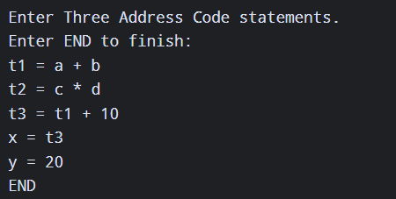
Sample output:
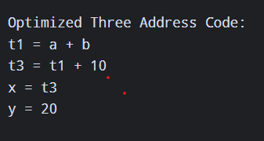

Result:
Thus, the C program successfully performs dead code elimination and displays the optimized Three Address Code by removing unnecessary statements.

